Elevatelabs-task5

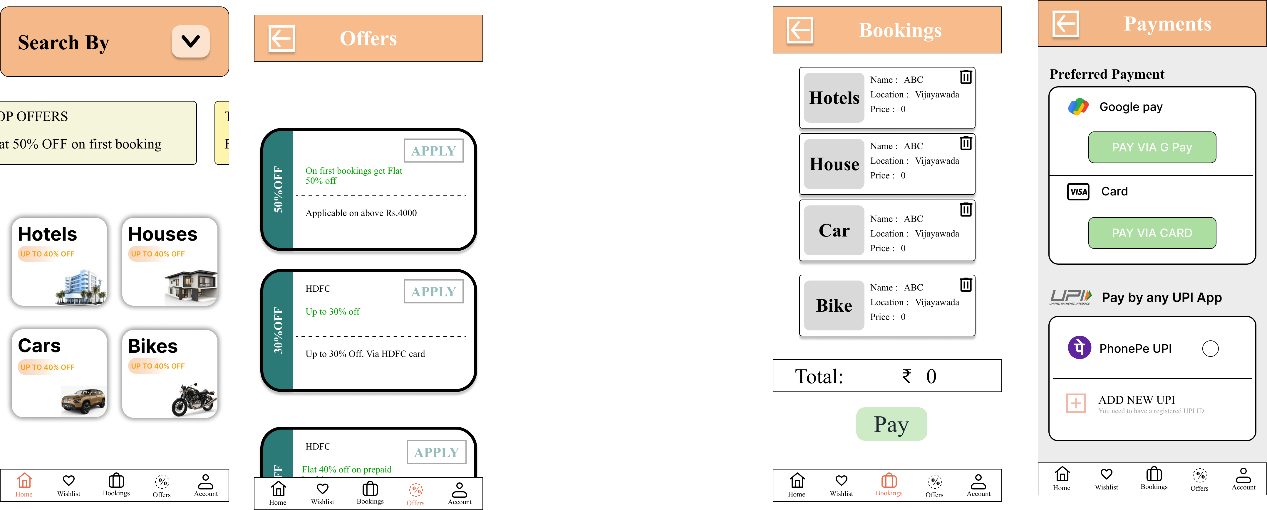

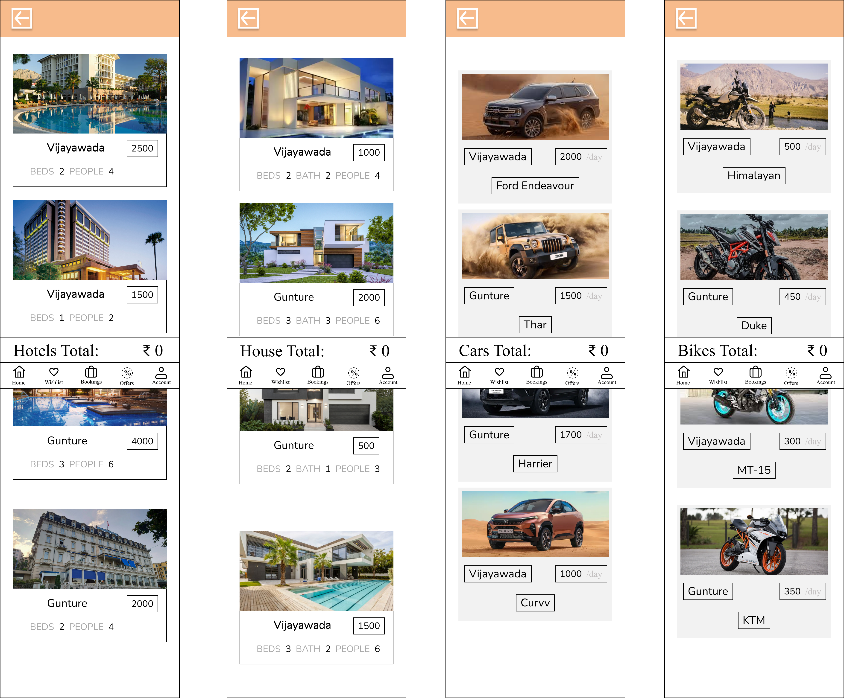

https://www.figma.com/design/tlvYRUPeYaqrFASB9nYf4X/vacation-rentals?node-id=47-940&t=hJhfD0FYYxnAoIIW-1

The user begins by selecting their preferred rental category, such as a car, bike, house, or hotel. After choosing the Car Rentals option, they are directed to the car listings page, where they can browse and select a vehicle of their choice. Upon clicking the “Book Now**”** button, the user is navigated to the payment page to securely complete their booking transaction.